I. LITERATURE REVIEW

In [1], authors discuss the influence of US dollar on setting of crude oil and gold rates in the international market. They also analyze the influence of US dollar with respect to mutual funds, financial markets, interest rates of Federal Reserve, inflation, and economic recession between the period 1996 and 2009. They take in to consideration major world events which may have affected US dollar rates. In [2], authors use the simplest approach to predict future gold rates, as they do not take into consideration any attribute that may directly or indirectly influence the gold rates. Instead, they only use five attributes derived from gold rates itself. These five attributes are the opening, closing, highest, and lowest price of gold on a given day, and the volume of the commodity traded that day. They use decision trees and support vector regression algorithms for predicting gold rates, but do not report any results. On the other hand, [6] perform a very comprehensive empirical comparison of seventeen different approaches for time series modeling of the gold prices, and conclude that random walk approach is the best. The shortcoming of the study is that they only use few variables such as the price of other precious metals (palladium, silver, etc.) as input variables to the models. They do not take into consideration the economic conditions of major economies, or gold producing companies. In [1], author use text mining and artificial neural networks (ANN) to forecast the gold prices and compare their results with the autoregressive-moving average (ARMA) model. ARMA model is the most frequently used statistical model for analyzing time series data. ARMA model consists of two parts, the first part AR, involves regressing the variable on its own past values. The second part MA, involves modeling the error term as a linear combination of error terms occurring simultaneously and at various times in the past. In [3] also, author use the ARMA model for predicting gold rates but use monthly rates of gold of past 124 months. They forecast actual gold prices and achieve an accuracy of 66.67%. In [10] also, author use ARMA model but compare their results with ANN and show that ANN performs better than ARMA. They used data from 1990 to 2006 for training, whereas data from 2006 to 2008 was used. For testing, Coefficient of determination (R2 ), mean absolute error (MAE), and root mean squared error were used for performance analysis. Cosine Amplitude Methods (CAM) test was also carried out for sensitivity analysis to determine relationship between related parameters. In [4], author use extreme learning machines (ELM) algorithm, a variation of ANN. They compare the results of ELM with feed forward neural network without feedback, with back propagation, radial basis function, and ELMAN networks. They conclude that ELM performs the best with accuracy of 93.82%. Variables considered by them include prices of gold, silver, and crude oil. They also consider Standard and Poor (S&P) 500 index and foreign exchange rate for preparing their model. In [5], authors take into consideration economic factors like inflation, currency prices, stock exchange performance, etc. to predict gold rates. They use multiple linear regression (MLR) model for forecasting gold prices based on eight independent variables. They conclude the most influencing parameters are Thomson Reuters Core Commodity (CRB) Index, EURUSD exchange rate, inflation rates, and money supply index (MI). Praise-Winsten procedure was used for removing correlated error terms. Using only these four attributes they achieved 96.92% accuracy. In [9], authors use logistic regression (LR) model and achieved 63.76% precision, 63.89% recall and 61.92% accuracy using eight years of data. They conclude that LR outperforms the SVM

II. Existing System

The investor and bank authorities depend on a person or a company who check the stock market and the view all trading in the world a by their experience they will give the advice to invest it depend on gold price also.

Basically, gold price is predicted by human.

III. Existing System disadvantages

Accuracy of the gold price prediction is not dependable when a human takes the role. so, it’s a very carefully investor step towards it.

24 hours of investigation in the market can predict the gold price.

It’s a big effort and time-consuming process

VI. Proposed System

The system provide a web app the predicted the gold price using Machine Learning.

User can view the current gold price in the market also some company rate

User get the mail if the predict price is greater than some company price

This system contain the third party system to known the news of agriculture based .

Training mage

Data processing

esemble

combineModel

input data

Data processing

Prediction

model

V. Proposed System advantage

This web app raped developed one which be a hand on hand to the grow to the user by they come to know the predicted value so they can plan to invest the money in their business to move up high in business market. We facilities the user to know the company who pricing below the predicted price through mail. Our web app is a user friendly one with more template, easy to handle with security

VI. Module

1. Admin Module
2. User Module
3. Shop owner Module

**Front End is django**

**backend python and sqlite3**

User

perdiction

data input

modle

View

Admin

User Verification

login

VII. Architecture

Input data

predicted

Table Design

**Admin_module**:

|  |  |  |
| --- | --- | --- |
| **Name** | **Type** | **Description** |
| **Id** | **Int** | **Id number** |
| **Username** | **Varchar** | **Username** |
| **Password** | **Varchar** | **password** |

**userModule:**

**user_reg**

|  |  |  |
| --- | --- | --- |
| **Name** | **Type** | **Description** |
| **Id** | **Int** | **Id number** |
| **Username** | **Varchar** | **Username** |
| **Password** | **Varchar** | **Password** |
| **Type** | **Varchar** | **usertype** |
| **Name** | **Varchar** | **Name** |
| **Email** | **Varchar** | **Email id** |
| **Contact** | **Varchar** | **Contact number** |
| **Upload** | **Varchar** | **Photo upload** |
| **Ver_id** | **Varchar** | **Verification id** |

**Prediction**

|  |  |  |
| --- | --- | --- |
| **Name** | **Type** | **Description** |
| **Id** | **Int** | **Id number** |
| **User_id foreign key** | **Varchar** | **User id no** |
| **Prediction** | **Varchar** | **Result text** |

**Shop owner**

|  |  |  |
| --- | --- | --- |
| **ShopName** | **Type** | **Description** |
| **Id** | **Int** | **Id number** |
| **Concat no** | **Varchar** | **Concat no** |
| **Email id** | **Varchar** | **Email id** |
| **password** | **Varchar** | **Password** |

**product**

|  |  |  |
| --- | --- | --- |
| **Product Name** | **Type** | **Description** |
| **Id** | **Int** | **Id number** |
| **prize** | **Varchar** | **Prize** |
| **Category** | **Varchar** | **Category** |
| **Weight** | **Varchar** | **Weight** |
| **Photo** | **Varchar** | **Photo** |

Level:0

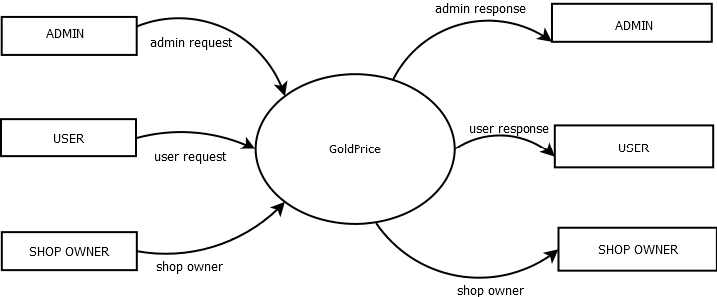

**Level:1**

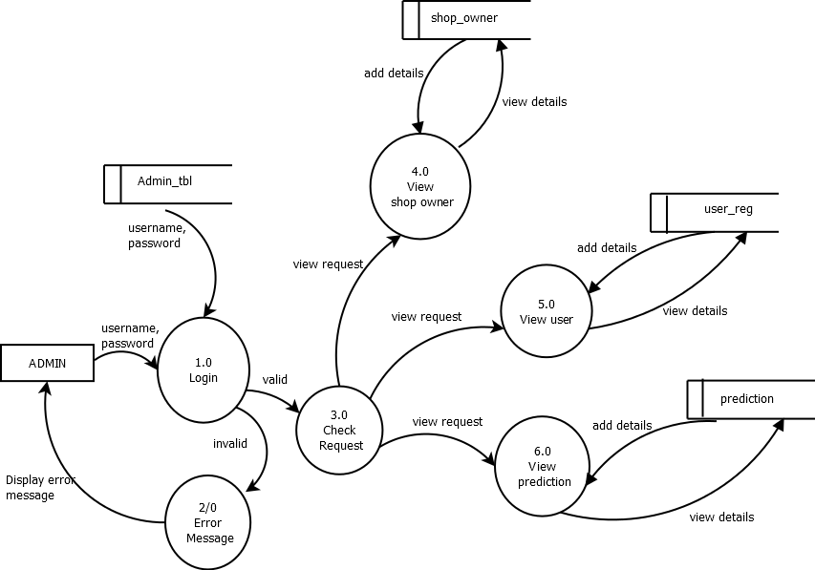

Level:2

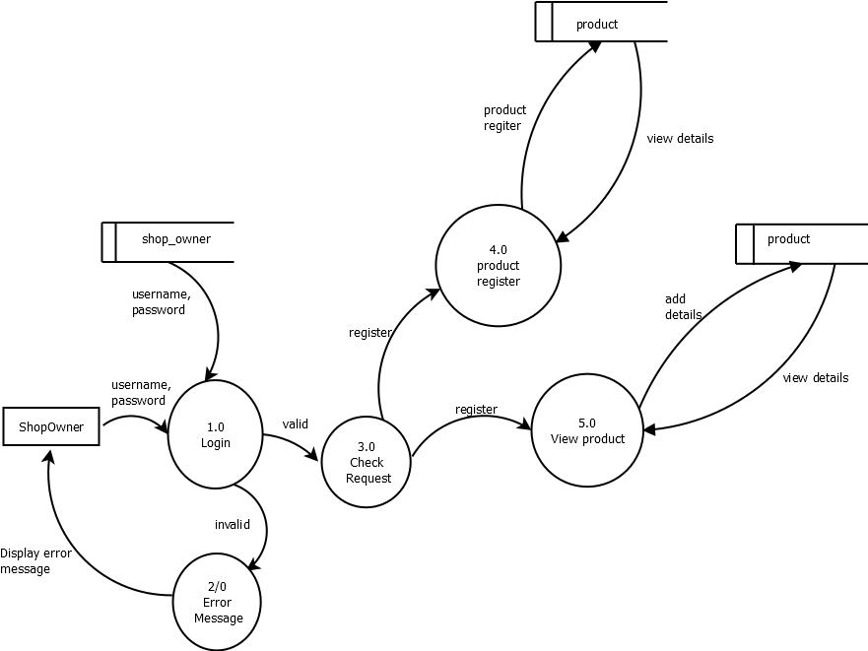

Level:3

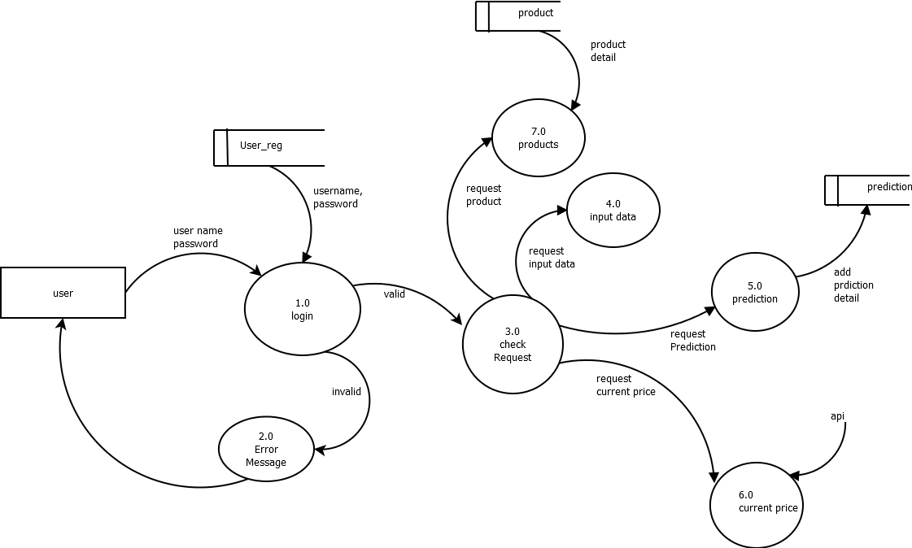

module description:

1. Admin Module
   1. View user and update delete them
   2. view prediction by user
   3. view Gold shop owner
2. User Module
   1. Current gold price
   2. View prediction /medicine display
   3. Third party link to know about the agriculture activities

Data flow :

Input train dataset

data processing

Model saving

Classification

Test data input

prediction

Model load